module parity_det_1always (x, rst, clk, z);

input x, rst, clk;
output z; reg z;

reg even_odd;

parameter EVEN = 0, ODD = 1;

always @(posedge clk, rst)
if (rst) begin
even_odd <= EVEN;
z <= 0;
end
else
case (even_odd)
EVEN: begin
z <= x? 1:0;
even_odd <= x? ODD:EVEN;
end
ODD: begin
z <= x? 0:1;
even_odd <= x? EVEN:ODD;
end
endcase

endmodule

module tst_parity_det;

reg x, rst, clk;
wire z;

parity_det_1always pd (x, rst, clk, z);

initial begin
clk = 0;
x = 0;
#10 x = 1;
#20 x = 0;
#20 x = 1;
#20 x = 0;
#20 x = 1;
end

initial begin
rst = 1;
#10 rst = 0;
end

always
#10 clk = ~clk;

endmodule

//Output of parity_det_1always

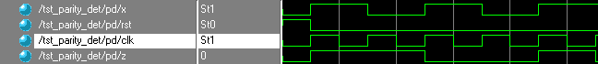

module parity_det_moore (x, rst, clk, z);

input x, rst, clk;
output z; reg z;

reg PS, NS;

parameter EVEN = 0, ODD = 1;

always @(posedge clk or rst)
if (rst)
PS <= EVEN;
else
PS <= NS;
always @(PS)
case (PS)
EVEN: z = EVEN;
ODD: z = ODD;
endcase

always @(PS or x)
case (PS)
EVEN: NS = x? ODD:EVEN;
ODD:NS = x? EVEN:ODD;
endcase

endmodule

module tst_parity_det;

reg x, rst, clk;
wire z;

parity_det_moore pd (x, rst, clk, z);

initial begin
clk = 0;
x = 0;
#10 x = 1;
#20 x = 0;
#20 x = 1;
#20 x = 0;
#20 x = 1;
end

initial begin
rst = 1;
#10 rst = 0;
end

always
#10 clk = ~clk;

endmodule

//Output of parity_det_moore

module parity_det_mealy (x, rst, clk, z);

input x, rst, clk;
output z; reg z;

reg PS, NS;

parameter EVEN = 0, ODD = 1;

always @(posedge clk or rst)
if (rst)
PS <= EVEN;
else
PS <= NS;

always @(PS or x)
case (PS)
EVEN: begin
z = x? 1:0;
NS = x? ODD:EVEN;
end
ODD: begin
z = x? 0:1;
NS = x? EVEN:ODD;
end
endcase

endmodule

module tst_parity_det;

reg x, rst, clk;
wire z;

parity_det_mealy pd (x, rst, clk, z);

initial begin
clk = 0;
x = 0;
#10 x = 1;
#20 x = 0;
#20 x = 1;
#20 x = 0;
#20 x = 1;

end
initial begin
rst = 1;
#10 rst = 0;
end

always
#10 clk = ~clk;

endmodule

//Output of parity_det_mealy

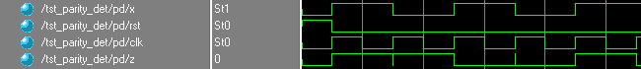

//Output of parity_det_1always



//Output of parity_det_moore

//Output of parity_det_mealy



